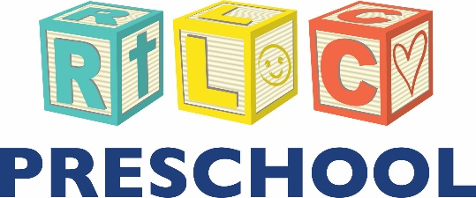

Information Sheet

Welcome! Thank you for visiting Resurrection Preschool & Daycare. Below you will find important information about our school that is perfect for first time visitors. If you have further questions or would like to register your child(ren), please contact the preschool director, Ms. Andrea Salgado at 602-485-1958 or andrea@rlc-scottsdale.org.

Student Information:
We enroll students ages 6 weeks to 4 years. Our curriculum is based around published child developmental milestones and grows with the student where creative academic learning helps prepare our pre-K students for Kindergarten readiness. Our teachers utilize kinesthetic activities to engage a variety of learning styles, and Christian principles are taught through bible stories and verses. Some extracurricular activities include music and PE.

Teacher and Staff Information:
Our teachers come to the classroom with coursework in Early Education that is enhanced with in-service training and continuous professional development opportunities. Their compassion and creativity make them people your child(ren) will remember fondly. We treasure our visits from past students .

Tuition Information:
Full time and part time (1-5 hours/day) packages are available, as well as specific rates for students who attend 2, 3, 4, or 5 days/week. Rates vary based on age. Please see the back of this sheet for current tuition rates/fees. Parents have access to convenient online account information and payment through myprocare.com.

Communication:
RLC Preschool & Daycare utilizes a closed (free) Shutterfly Share Site to update families on events, school news, teacher notes, pictures, etc. It is the hub of school information available 24/7 at your fingertips.

